MATWIN is a French open-innovation platform aiming at selecting and supporting preclinical or early clinical innovations in oncology to optimise their transfer potential for partners (pharma companies, biotechs, investors, etc.). The present form should describe your project from a translational point of view. To access our support, the project will first be reviewed and preselected to have access to a first level of evaluation by the MATWIN International Board. For assistance do not hesitate to ask your Technology Transfer Office and/or institutional partner (Canceropole, research institution…) or MATWIN.

Research Project

Title
Acronym
Key words

Project Coordinator

Title; Name
Position
Lab / Organisation
Address
E-mail |  | Phone / Mobile

For European project outside France – French established collaborator

Collaboration type
Title; Name
Position
Lab / Organisation
Address
E-mail |  | Phone / Mobile

Technology Transfer Office (for academic team) / Patent Office (for start-up)

Name
Contact name
Address
E-mail |  | Phone / Mobile
- ABSTRACT (400 words MAX - NOT CONFIDENTIAL)

(Summarize your project as NOT confidential, to allow diffusion to peers without jeopardizing proprietary information). Only the abstract must be considered as NOT confidential.
Please, note that your summary must answers the followings and indicate your French established collaboration (for NON French European applicants only):
1. Application domain
2. Innovative component / Competitive differentiator
3. Objectives
4. Concept
5. Methodology
6. Expected results
7. Impact

- INTELLECTUAL PROPERTY

Patent one table for each patent, filed or granted

Patent title
Date of patent filing
Patent co-owners (institutions)
National / PCT / WO number
Freedom To Operate ? Y/N - Patent officer
(1 page summary to be joined)
Potential agreement (license) limiting use of IP? Involved parties & type of agreement?

- SCIENTIFIC PROJECT (4-5 PAGES MAX - CONFIDENTIAL)

- Context and background (A HALF PAGE MAX): Describe succinctly the context and the goal to be reached including the 4-5 more relevant publication references.

- Current stage of development (3-4 PAGES MAX): Describe the project’s development stage relative to the goal to be reached (bullet points), including the essential / relevant datas justifying your claims regarding the mechanism of action, the proof of concept, benchmarking, etc. with 3-4 figures of the most relevant and differentiating data.

- Research & development plan (A HALF PAGE MAX): List (bullet points) the main steps and GO/No GO to achieve the final goal

UNDERTAKING

Project Leader (and TTO representative if applicable)
The parties, undersigned confirm that they (i) completed all sections and that all information given in this form is complete and true, (ii) obtained the agreement of collaborators and institutional contacts for their participation (iii) fully agree with the Charter on Rights and Duties of MATWIN applicants (see attached Appendix). The parties authorise MATWIN to share this application form for assessment, given that each person who accesses this document is engaged through a confidentiality agreement with MATWIN (as described in the attached MATWIN Charter).

Name of the leader applicant : | Name of the TTO legal representative :
Date and Signature | Date and Signature
File to be sent to: contact@matwin.fr before November 10th, 2022

APPENDIX – IMPORTANT (to be read before applying)
MATWIN Charter - Rights and Duties

MATWIN, a subsidiary of the Unicancer group (the federation gathering the 18 French Comprehensive Cancer Centres), is the only open innovation platform fully dedicated to accelerating early innovation in oncology. MATWIN carries out its acceleration programme in partnership with major international companies willing to increase collaborative opportunities in the field. MATWIN programme aims at optimizing the development plan of preclinical (or early clinical) innovative projects and accelerating their time to market. The programme is designed to operate at the forefront of the project’s acceleration phase (assessment of the technological value, asset identification, value proposition, coaching and access to a network of industrial partners and investors). Since its creation in 2009, MATWIN has accompanied more than 260 projects led by either academic teams or startups.
MATWIN’s operational decisions rely on the MATWIN International Board (referred to “MIB”), an international multidisciplinary Board which meets annually gathering around twenty internationally renowned members: Global R&D Oncology executives from MATWIN industrial partners and academic leaders / experts from major European cancer organisations. This committee meets once a year in France on a MATWIN initiative to review the projects, assess their development potential, and label the best ones for possible partnerships.
The MATWIN applicants can be either academic teams or young companies (creation ≤ 7/8 years); they must be domiciliated in Europe (UK, Switzerland, Norway included). When applying to MATWIN, the applicants (and their Technology Transfer Office when applicable) have to agree with the following Rights and Duties of MATWIN and candidates. They also agree, if selected by the MIB to access MATWIN support, to sign an agreement with MATWIN addressing the different items below.

MATWIN’s duties
- Best practices
The MATWIN Programme has been implemented according to the best practices to meet the requirements of technology transfer at the preclinical/early clinical stage.
MATWIN undertakes to make every effort with the support of the major research and care institutions, to:
  - Identify the best projects in oncology from the whole European territory;
  - Help to structure these projects in accordance with the industrial partners’ requirements;
  - Shorten the development period to boost the availability for patients of possible therapeutic innovations.

- Applicants visibility
MATWIN undertakes to give the best visibility to every selected project to reinforce sourcing opportunities.
MATWIN undertakes to raise greater awareness of every selected project by providing access to the industrial partners represented at the highest level on the MATWIN Board (International Global executives, Early development, drug discovery or oncology experts) of all the necessary documents to ease its assessment.
MATWIN undertakes to provide all necessary efforts to facilitate intermediation between selected projects after the MATWIN support with MATWIN partners or external partners.

In case of a potential interest by company members in one or several projects presented to the MIB, MATWIN Partners may mandate MATWIN to provide support in coordinating and following the exchanges with the applicants and IP owners (and/or their legal representatives) until the signature of a potential partnership or transfer agreement regarding the concerned project(s). On top of these, MATWIN undertakes to provide all necessary efforts all along the programme and after to facilitate intermediation with any relevant partner for the project (Technology Transfer Offices, Biotech companies, Investors …).

- Confidentiality
MATWIN undertakes ensuring confidentiality related to every submitted project by prohibiting internal and external communication of any confidential document without the applicant's prior written approval.
Each stakeholder of the MATWIN programme (MATWIN employees, experts, coaches, members and invited members of the MATWIN Board) undertakes not to publish or disclose under no circumstances the confidential scientific or technical information and data belonging to the applicants by signing a confidential agreement with MATWIN prior having access to any of the information.

The Applicant’s duties
- Best practices and divulgation
The applicant guarantees the accuracy of scientific data presented all along the MATWIN Programme as well as their origin. It also undertakes to provide all necessary scientific information and data all along the MATWIN process for an optimal assessment of the project according to MATWIN's confidentiality duties. In case the applicant may refuse to share the requested scientific information and data, he takes the risk of being excluded from the MATWIN Programme.

- Transparency / Information / Communication
The applicant must keep MATWIN informed of any discussion and any agreement that may be initiated or signed as a consequence of the MATWIN Programme during or post MATWIN support.
This encompasses:
- Maturation or extension of a maturation programme agreed with a Technology Transfer Office
- Start-up creation
- Collaboration or co-development agreement, licensing agreement
- Funding agreement, fundraising, crowdfunding, etc.

The applicant must associate MATWIN with any successful collaboration post-MIB exposure with any partner (from MATWIN or not) and communicate on the facilitating / accelerating role of MATWIN in the setting up of this successful collaboration (e.g press releases, interviews, websites, professional networks).

- Financial duties
To benefit from the MATWIN process, a fee of 1.000€ (tax excl.) has to be paid by all applicants if selected by the MIB. This access fee allows applicants to benefit from the whole MATWIN support without paying in advance the MATWIN support costs (see art. 3.1 “MATWIN Programme support”).
- Full support (6 months): 1.000€ to be paid if selected after the 1st written feedback from MIB (January)
- Fast track support (3 months): 1.000€ to be paid if the application is selected by the MIB (April)
The access fee already paid to access the MATWIN support will be deducted from the total support costs (see 3.1)
Post MATWIN support, the reimbursement of the MATWIN Programme support by the applicant is based on a success fee principle including:
- the reimbursement of the MATWIN Programme support (see 3.1)
- a partnership success fee only if the success is directly linked to a MATWIN intermediation (see 3.2)

  - Reimbursement of the MATWIN Programme support
The MATWIN applicant undertakes to reimburse the overall MATWIN support cost he/she benefited from, in case of any funding agreement that may be concluded within a 3-year period post MIB exposure
This encompasses:
- Any agreement generating extra revenues for the project (collaboration, codevelopment, licensing agreement or licensing option or any transfer agreement)
- Any funding agreement, fundraising, crowdfunding, etc.

The costs associated with the MATWIN support to be further reimbursed are listed below (tax excluded):
- Step 1 = Written feedback from MIB post preselection pitch 1.000 €
- Step 2 = Coaching - 2 sessions: Development plan review + Training before MIB meeting: 4.500 €
- Step 3 = Board presentation + written feedback from each Board member & final MATWIN synthesis: 4.500 €

MATWIN’s usual support process (6 months) | MATWIN’s fast track support process (3 months)
Having access to Step 1 + 2 + 3  If selected for the final MIB presentation, the total cost of the MATWIN usual support is 10.000 € tax excl. | Having access to half of Step 2 + Step 3  If selected for the final MIB presentation, the total cost of the MATWIN fast-track support is 5.000 € tax excl.
The access fee of 1.000€ already paid to access the MATWIN support will be deducted from the total support costs.

3.2 Partnership success fee
Only in case of any success that may be concluded thanks to a MATWIN intermediation (see below) post MIB exposure within a 3-year period, the applicant undertakes to pay a success fee of 10.000 € (tax excl) to MATWIN:
- if the applicant is a private company when applying for the MATWIN support
- if the applicant was an academic when applying but has turned into a newly formed company post MATWIN support (the partnership success fee will then be covered by the newly formed company)

A success resulting from a MATWIN intermediation is defined below as any agreement / funding opportunity generating a first phase of funding for the preclinical or clinical development of the project with:
- An already established partner of the MATWIN programme
- An external partner introduced by MATWIN with whom the applicant was not already in touch with (or if in touch, with a different representative)
When applying for the MATWIN support, the applicant agrees to sign with MATWIN an agreement addressing both MATWIN and applicant’s Rights and Duties.
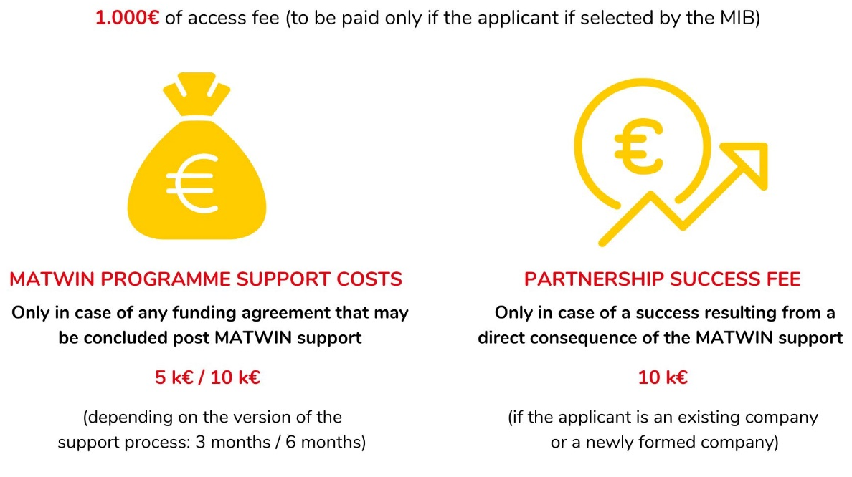

Fabrice BARLESI
MATWIN President

